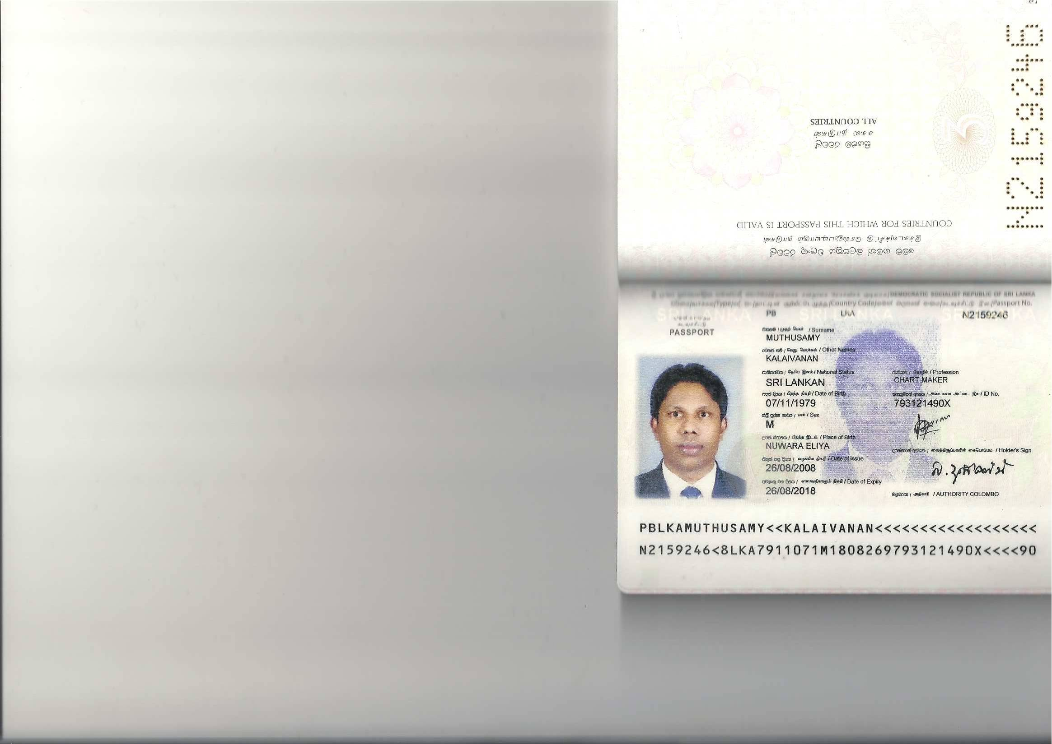**Curriculum vitae**

**Muthusamy kalaivanan**

**No -17 swatch farm road Vajira pura**

**Nuwara Eliya**

**E-mail** [**–kalaivananm@hotmail.com**](mailto:–kalaivananm@hotmail.com)

**PERSONAL INFORMATION**

**Name in full : Muthusamy kalaivanan**

**Date of birth : 7th November 1979**

**Nationality : Sri Lanka**

**Civil status : UN married**

**Linguistic skills : English, Sinhala, and Tamil**

**Passport no : PBLKAN2159246**

**Driving license no : D.L.NO18163936**

**Skype id -: kalaivanan360**

**CONTACT DETAILS**

**Address : No-17 swatch Farm Road Vajira pura**

**Nuwara Eliya**

**Contact Number : Home +94 052-4920083**

**Mobile-+94 071-2200407**

**E-mail : kalaivananm@hotmail.com**

**WORK EXPERIENCE**

* **Presently working at innovative knit wear (pvt) ltd as a sample and technical executive 2012till date.**

**Specialization areas of**

* **Estimate time and weight.**
* **Yarn and fabric calculation**
* **Chart marking**
* **Cost reducing**
* **Customer wise perfect sample sending :- m&s, hanky doory, white stuff, srilanka cricket**
* **Production size set marking**
* **Arrange pp meting and discus to do production problems.**
* **And particle knowledge line balance, production planning for shipment date**
* **Practical knowledge of the production process. From knitting (hand knit and computerized)**
* **Linking operations, stitching/mending and over lock. Ironing, washing packing.**
* **In line final inspection systems (AQL).**
* **Knowledge of e-mail internet**
* **Worked at Eskimo fashion knit wear 2011to2012 as a quality executive**
* **Worked as a production section in charge at ran maul fashion 2001to 2011**

**PROFESSIONAL QULIFICATION**

* **I have followed a diploma course in Department of textile& clothing technology university of Moratuwa Sri Lanka. Production organization and management.**

**OTHER QULIFICATION**

* **I have followed a diploma course in computer office package at Intel computer centre. Nuwara Eliya.**
* **I have followed a computer course in windows 7 office package at British informatics of computer technology Wellawatha.**

**EDUCATIONAL QUALIFICATION**

**Junior technical certificate examination-1993**

**Obtained merit pass in commerce and finance conducted by department of examination in Sri-Lanka.**

**Examination : G.C.E (advance level)**

**School : Holy Trinity College**

**Year : 1998August**

|  |  |
| --- | --- |
| **subject** | **Grade** |
| **Commerce** | **Credit pass** |
| **Geography** | **Credit pass** |
| **Economics** | **Simple pass** |
| **accounts** | **Simple pass** |

**Examination : G.C.E (ordinary level)**

**School : St.Xaviers College, Nuwara Eliya**

**Year : 1995 December**

|  |  |  |
| --- | --- | --- |
| **subject** | **Grade** | |
| **Commerce and finance** | **Distance pass** | |
| **Social studies** | **Credit pass** | |
| **Tamil** | **Credit pass** | |
| **Reglion** | **Credit pass** | |
| **Science** | **simple pass** | |
| **Maths** | **simple pass** | |
| **English simple pass** | |

**EXTRA CURRICULAR ACTIVITIES**

* **School prefect.**
* **President of literacy society.**
* **President of the peace community at the school level.**
* **Re presented the holy trinity college for speech and debate at provincial level.**
* **Played football, cricket and track events at school level.**

**NON-RELATED REFEREES**

**Mr.parakrama (general manager) innovative knit wear (pvt) ltd.**

**Malwathu goda galagedra**

**Kandy.MOBILE :-077-8016677**

**Mr.vivekanandan**

**Attorney –at low**

**Kandy road**

**Nuwara eliya.**

**I hereby certify that the above information stated this document is true and accurate to the best of my knowledge.**

**Thank you, yours truly, M.kalaivanan.**